PANCAR WAHYU SETIABI

H1D024018

SHIF D

1. Modify table (mengubah tipe data)

MariaDB [penjualan_barang]> desc nama_pelanggan;

+--------------+--------------+------+-----+---------+-------+

| Field | Type | Null | Key | Default | Extra |

+--------------+--------------+------+-----+---------+-------+

| id_pelanggan | char(5) | NO | PRI | NULL | |

| nama | varchar(25) | NO | | NULL | |

| alamat | varchar(100) | YES | | NULL | |

| pekerjaan | varchar(20) | YES | | NULL | |

| no_ktp | int(20) | YES | | NULL | |

| no_telp | int(15) | YES | | NULL | |

+--------------+--------------+------+-----+---------+-------+

6 rows in set (0.019 sec)

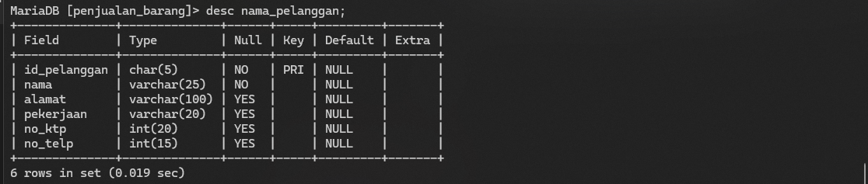

MariaDB [penjualan_barang]> alter table nama_pelanggan modify nama char (20);

Query OK, 0 rows affected (0.103 sec)

Records: 0 Duplicates: 0 Warnings: 0

MariaDB [penjualan_barang]> desc nama_pelanggan;

+--------------+--------------+------+-----+---------+-------+

| Field | Type | Null | Key | Default | Extra |

+--------------+--------------+------+-----+---------+-------+

| id_pelanggan | char(5) | NO | PRI | NULL | |

| nama | char(20) | YES | | NULL | |

| alamat | varchar(100) | YES | | NULL | |

| pekerjaan | varchar(20) | YES | | NULL | |

| no_ktp | int(20) | YES | | NULL | |

| no_telp | int(15) | YES | | NULL | |

+--------------+--------------+------+-----+---------+-------+

6 rows in set (0.028 sec)

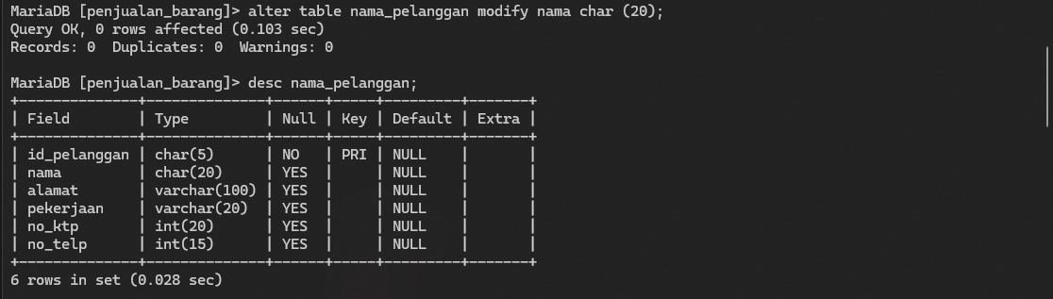

1. Menghapus table

MariaDB [penjualan_barang]> show tables;

+----------------------------+

| Tables_in_penjualan_barang |

+----------------------------+

| barang |

| detail_jual |

| nama_pelanggan |

| nota_penjualan |

+----------------------------+

4 rows in set (0.001 sec)

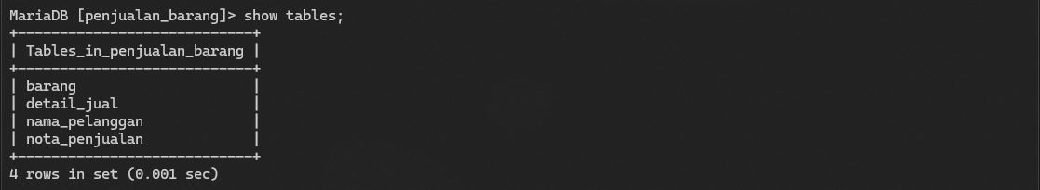

MariaDB [penjualan_barang]> drop table detail_jual;

Query OK, 0 rows affected (0.011 sec)

MariaDB [penjualan_barang]> show tables;

+----------------------------+

| Tables_in_penjualan_barang |

+----------------------------+

| barang |

| nama_pelanggan |

| nota_penjualan |

+----------------------------+

3 rows in set (0.001 sec)

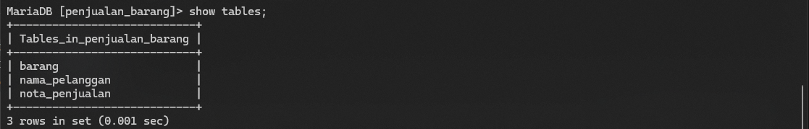

1. Mengganti nama table

MariaDB [penjualan_barang]> show tables;

+----------------------------+

| Tables_in_penjualan_barang |

+----------------------------+

| barang |

| detail_jual |

| nota_penjualan |

| pelanggan |

+----------------------------+

4 rows in set (0.001 sec)

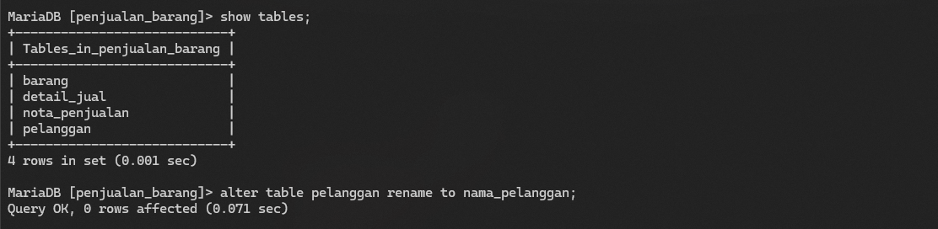

MariaDB [penjualan_barang]> alter table pelanggan rename to nama_pelanggan;

Query OK, 0 rows affected (0.071 sec)

MariaDB [penjualan_barang]> show tables;

+----------------------------+

| Tables_in_penjualan_barang |

+----------------------------+

| barang |

| detail_jual |

| nama_pelanggan |

| nota_penjualan |

+----------------------------+

4 rows in set (0.001 sec)

